NDG Labs: Capstone Part 2 (Worth 50% of the Capstone Grade)

To complete the lab, you must upload this document with your screenshots inserted.
Submitting any document other than this document, will result in a score of 1 for this lab.
For this lab, not correctly performing or missing the Final Screenshot will cost you 99 points.

For this lab, follow the lab direction in this Lab Document. Use the Snipping Tool, or equivalent, to capture the required screenshots.
Follow the instructions for how to properly capture a screenshot provided in the NDG Lab Instructions and Lab 2 Student Template document in the Assignments Folder under NDG Lab Instructions, How-to-Videos, and Module 2 Lab Student Template.

When doing your capstone:
- Review this template to ensure which screenshots you must provide to prove you have completed this portion of the Capstone correctly.

- Screenshots for Part 2 are to be taken after you have completed all parts of this lab, but prior to ending your reservation.

- If a field/box will not allow you to paste your screenshot, it has something to do with the upload/download process in Blackboard. You will need to download this document again and transfer the screenshots you have captured over to the new downloaded template and continue with the lab.

Screenshots required for this lab: Total of 21

Warning:

For this Capstone, not correctly performing or missing the Final Screenshot will cost you 99 points.

If you need to review how to perform the Final Screenshot, view the demonstration video linked below.
https://us-lti.bbcollab.com/recording/f7b9839afae84a17a084385d1b7f99e1

It is highly recommended that you schedule plenty of time to complete Part 2 of the Capstone lab since you only have 3 attempts (Capstone Reservations that you can make this week) See the next page for more details.

You can make an 8-hour reservation and extend it up to 8 times (once the timer reaches 15 minutes) if no other student has reserved the same POD following your current reservation.

Once you have completed your lab, end your reservation so that others can use that POD.

CAPSTONE REQUIREMENT
- All your Capstone screenshots must come from the same reservation.

- You are allowed only three attempts at Capstone Part 1.
  - You can only create three Lab 17: Capstone Lab reservations in NDG during this week of the Capstone (exception to this is below).
    - You will be allowed three more Capstone reservations when Captone 2 is available.
  - You may review other labs/exercises you have performed, to include, making reservations of those labs during this period. Making a reservation for labs 3, 4, 5, etc. is not Lab 17: Captone and does not count as one of your three Lab 17: Capstone reservations.
  - You must perform your Capstone Part 1 lab using only Lab 17:Capstone in NDG.
  - If you have any concerns about your own PC or internet connection, you will want to find a stable setup to perform this lab, especially if you are having to make your third reservation.
    - Your Capstone will not be accepted if you make more than three Lab 17:Capstone reservations a week (minus the exception below)

- Your lab must be uploaded to Blackboard in Landscape Mode to get a grade above a 1.

- If the NDG Lab firewall does not recognize the admin password Pal0Alt0! at the start of your lab.
  - Capture a screenshot of the issue, ensuring the POD number used for your reservation, is visible in your screenshot.
  - Cancel your current reservation, allowing no more than 5 minutes of your reservation time to pass before canceling it.
  - Email your instructor, being sure to attach the screenshot, and explain what POD you were on when it occurred.
  - Finally, make a new reservation on a different POD and restart your Capstone Lab
    - This reservation will not count against one of your three allocations, if you ended the reservation within the 5 minutes above.

- Incorrect screenshots are worth 4.5 points each.

- Incorrect format for your screenshot is a 2-point deduction per screenshot, up to 11 points.

- Not performing the Final Screenshot correctly will cost you 99 points.

- Not uploading your work as a PDF is a 5-point deduction.

- The Naming Convention of policies, profiles, lists, etc., must follow what was provided on this document.

Lab 17: Capstone

Introduction

This is part 2 of a comprehensive lab intended to enable you to test your new knowledge and skills. You can refer to your student PPTs and previous lab exercises.

In this scenario, you are a firewall administrator and recently received a Palo Alto Networks VM Series firewall that was partially completed. Your tasks is to complete the firewall configuration. The firewall’s management IP address is 192.168.1.254. You can log in with the username admin and Pal0Alt0! as the password.
Take special care to use the exact spelling and capitalization for the items you are tasked with configuring.

Objective
You are being asked to meet multiple configuration objectives. These objectives are listed in the lab exercise sections that follow.

Lab Topology

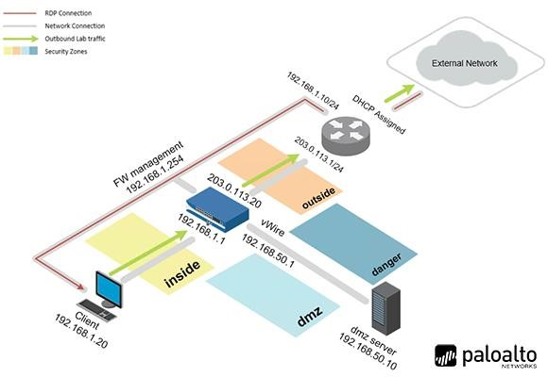

Capstone Part 2

Load Lab Configuration

- In NDG, reserve Lab 17: Capstone to complete the lab.
  - For PART 2 you MUST select a POD in NDG that has CAP2 in the POD name.
  - CAP2 pods will be all the way to the right (after PAN10_2024FA_POD_25. (see figure below) (If you have not used a pod other that the first four when you log in, you click the > to the right (see red circle) to see other PODs available.
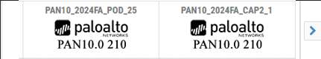

  - Do not use the NDG Contents from NDG for the Capstone. Your lab instructions are in this document.
  - Ensure you complete Part 2 in a single NDG reservation. (If you start over, ensure that you retake all screenshots so that they all come from the same NDG reservation).
- In the web interface, select Device > Setup > Operations.
- Click Load named configuration snapshot.
- Select Capstone2 and click OK.
- Click Close.
- Commit all changes.

Continued from Capstone Part 1

  - Create and Apply Security Profiles

Create Security Profiles and add them to a Security Profiles Group named Corp-SPG to meet the following requirements:
- A Corporate URL Filtering Security Profile named Corp-URL to log access to all web categories.
- Using the default profile as the basis for the Corp-URL profile, alter it to also block access to the following categories:
    - high-risk
    - games
    - nudity
    - swimsuits and intimate apparel
    - newly-registered-domain

- A Corporate File Blocking Security Profile named Corp-FB to block dangerous file types.
  - Ensure the Corp-FB profile uses the same settings as the strict profile.

- A Corporate Antivirus Security Profile named Corp-AV to block viruses.
- Using the default profile as the basis for the Corp-AV, alter it as follows:
    - Add the following description to your profile “Level 3 analysts need PCAPs”
    - Ensure your profile conducts packet captures.

- A Corporate Anti-Spyware Security Profile named Corp-AS to block viruses.
- Ensure the Corp-AS profile uses the same settings as the strict profile.

- A Corporate Vulnerability Protection Security Profile named Corp-Vuln to block viruses.
- Ensure the Corp-Vuln profile uses the same settings as the strict profile.

- A Corporate WildFire Profile named Corp-WF to send all file types to the public cloud for inspection.
- Ensure the Corp-WF profile uses the same settings as the default profile.

Configure Custom Security Policy Rules

Create custom security policy rules to meet the following requirements:
- For all custom security policy rules, enter a helpful Description.

- Apply the following Tags to the Security policy rules, as appropriate:
- Allow – Lime
- Block – Red

- From the User zone to the Extranet zone, create a security policy rule named Users_to_Extranet to allow the following applications:
- ping
- ssl
- ssh
- dns
- web-browsing

- From the User zone to the Internet zone, create a security policy rule named Users_to_Internet to allow the following applications:
- ping
- dns
- web-browsing
- ssl

- From the Extranet zone to the Internet zone, create a security policy rule named Extranet_to_Internet to allow the following applications:
- ping
- dns
- web-browsing
- ssl

- Create a security policy rule named Block_Bad_URLs with the following characteristics:
  - For all outbound traffic, the URL categories hacking, phishing, malware, and unknown must be blocked by a security policy rule match criterion.

- Add the Security Profiles Group to all appropriate policies.

Now that you have completed the configuration of the firewall, on the following pages, provide the correct screenshots proving you have completed the above tasks correctly.
Initial Setup Part 1 – (From the NDG Menu Bar, click on the Client Tab drop down arrow and select Actual Size. Next, click Applications (bottom left) and go to Setting > Display. Take a screenshot of the Display Window showing the Resolution is 1280x768. Ensure you have aligned your PC browser correctly so that your NDG username, the Time Remaining and Trash are aligned. Those with laptop displays less than 1080p, ensure you have adjusted your zoom properly)

Initial Setup Part 2 – Click on the Firewall tab and ENSURE that the firewall has completely loaded, prior to starting the Capstone.

You are not providing the above screenshots
This is to remind you of how your screenshots need to be set up and to ensure the firewall is ready, prior to beginning.

NOTICE TO STUDENTS:
For the POLICIES > Security page screenshots, you must remove the following columns prior to taking the screenshots:
- Source User
- Type

Screenshot 1 - After completing the firewall setup, provide a screenshot ensuring the policy in row 1 on the Policies > Security page is visible, confirming you have completed some of the objectives of the Capstone. Ensure the columns Name over to Options are visible in your screenshot. Ensure all necessary columns, column information and changes you made are fully visible in the screenshot.
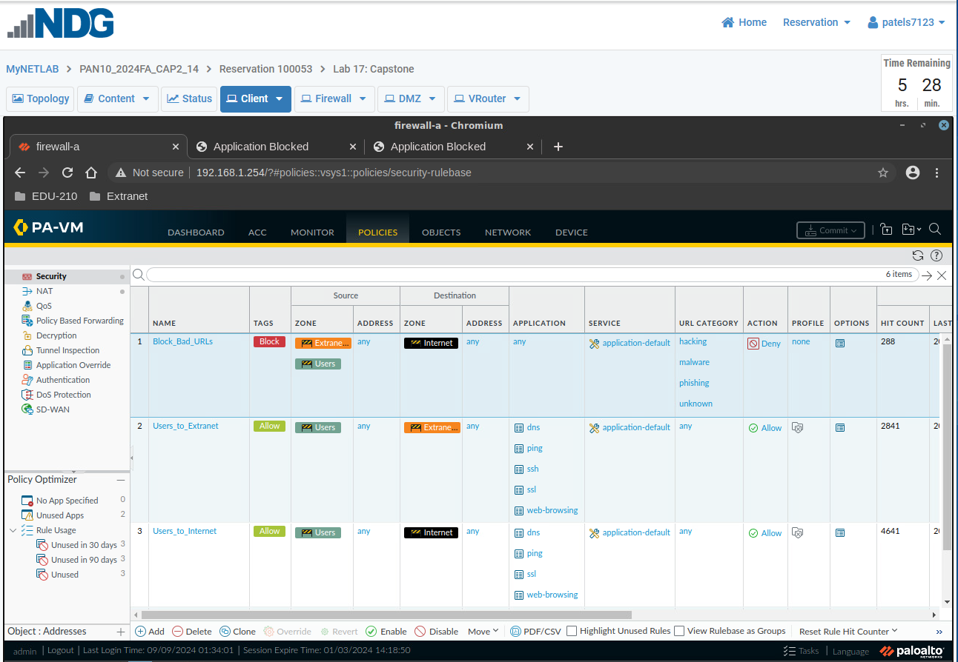

Screenshot 2 - After completing the firewall setup, provide a screenshot ensuring the policy in row 2 on the Policies > Security page is visible, confirming you have completed some of the objectives of the Capstone. Ensure the columns Name over to Options are visible in your screenshot. Ensure all necessary columns, column information and changes you made are fully visible in the screenshot.


Screenshot 3 - After completing the firewall setup, provide a screenshot ensuring the policy in row 3 on the Policies > Security page is visible, confirming you have completed some of the objectives of the Capstone. Ensure the columns Name over to Options are visible in your screenshot. Ensure all necessary columns, column information and changes you made are fully visible in the screenshot.
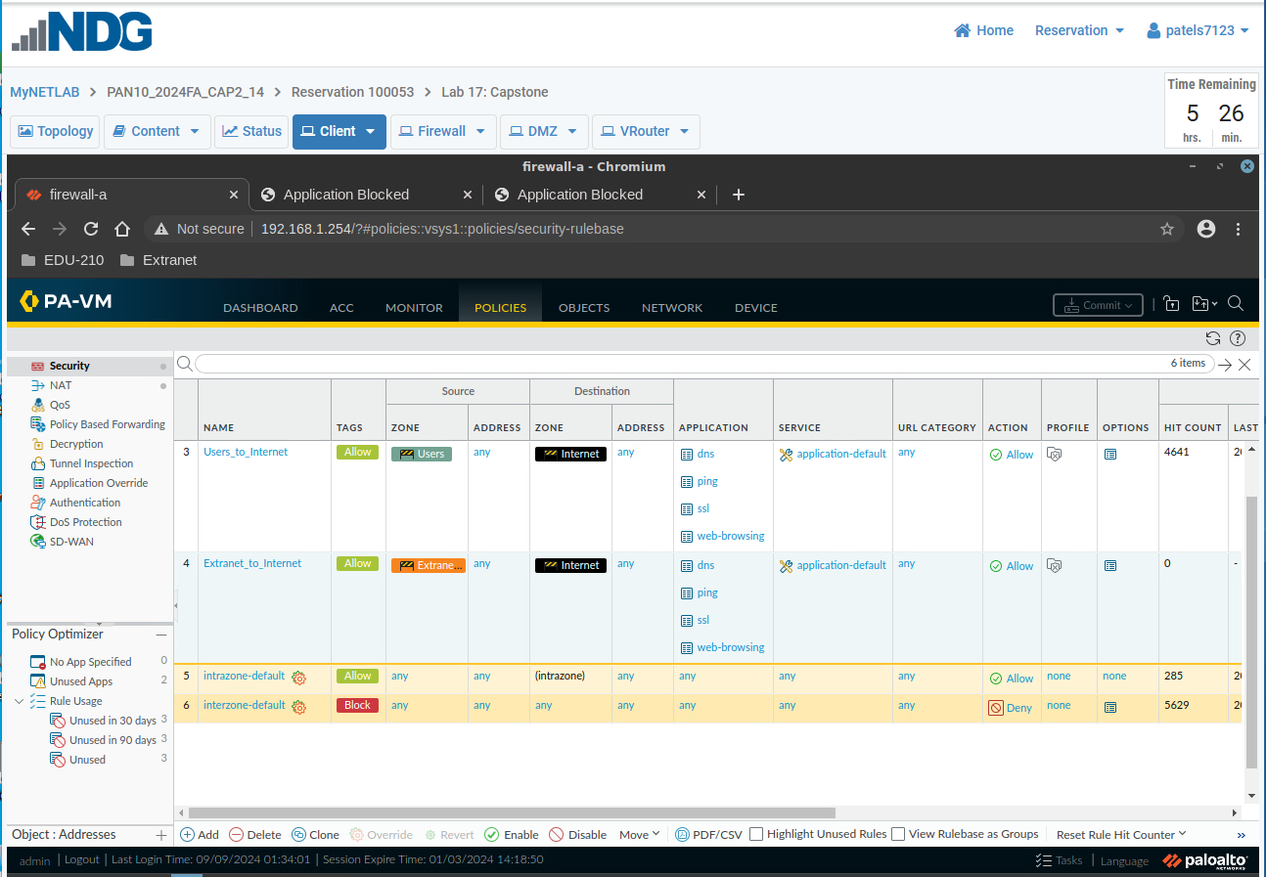

Screenshot 4 - After completing the firewall setup, provide a screenshot ensuring the policy in row 4 on the Policies > Security page is visible, confirming you have completed some of the objectives of the Capstone. Ensure the columns Name over to Options are visible in your screenshot. Ensure all necessary columns, column information and changes you made are fully visible in the screenshot.


Screenshot 5 - After completing the firewall setup, provide a screenshot showing that you completed task 17.7 Step 1 for the Security Policy Block_Bad_URLs.

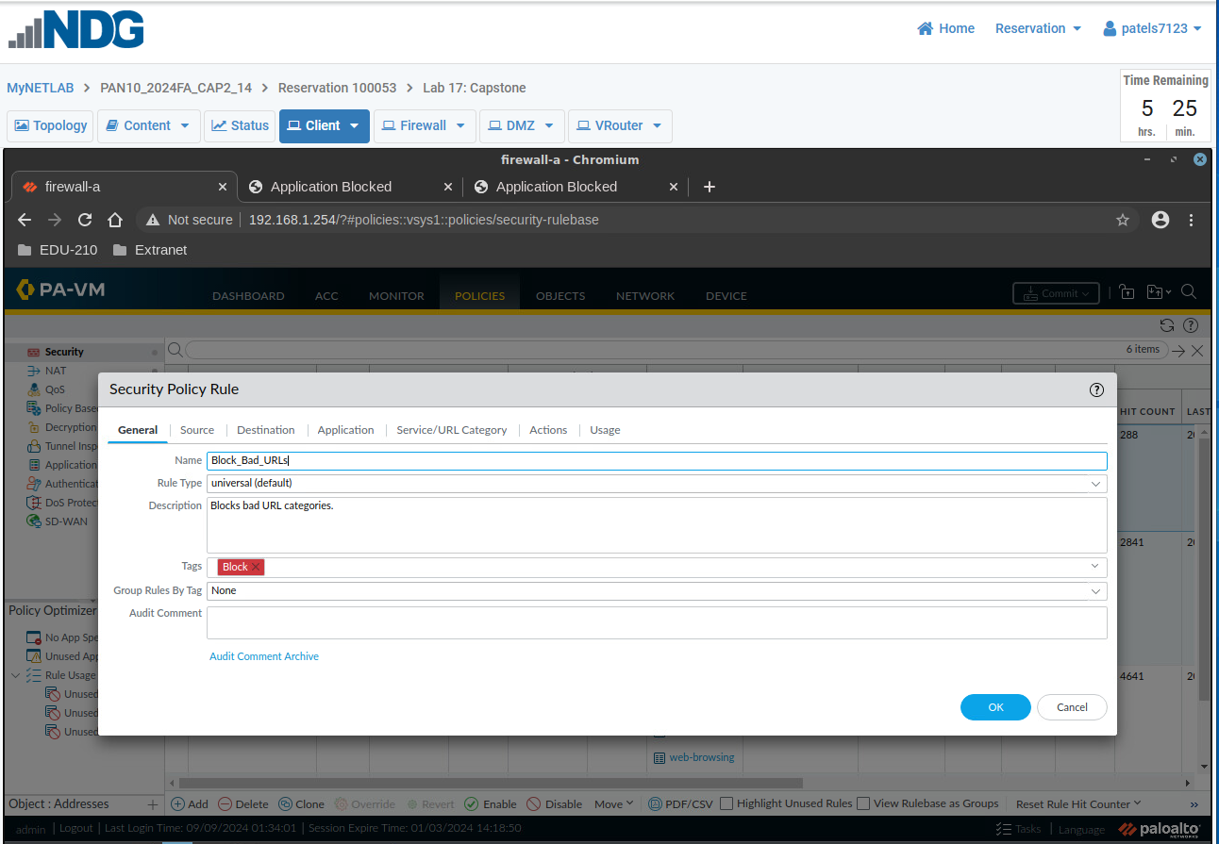

NOTICE TO STUDENTS:
For the terminal and Remmina screenshots:
- You must make the terminal and Remmina windows fullscreen prior to taking your screenshots

- You must clear the terminal/Remmina prior to issuing a new command (you can only have one command and one output visible in each screenshot)

Screenshot 6 - After completing the firewall setup, provide a screenshot showing that the client host, from the client terminal, can ping 8.8.8.8 and receive a response. Do not let the ping run for too long.
The command you entered, and the full ping statistics output, must be visible in your screenshot. Ensure only one command and its output is in the screenshot (i.e. clear the CLI screen prior to conducting the command above).
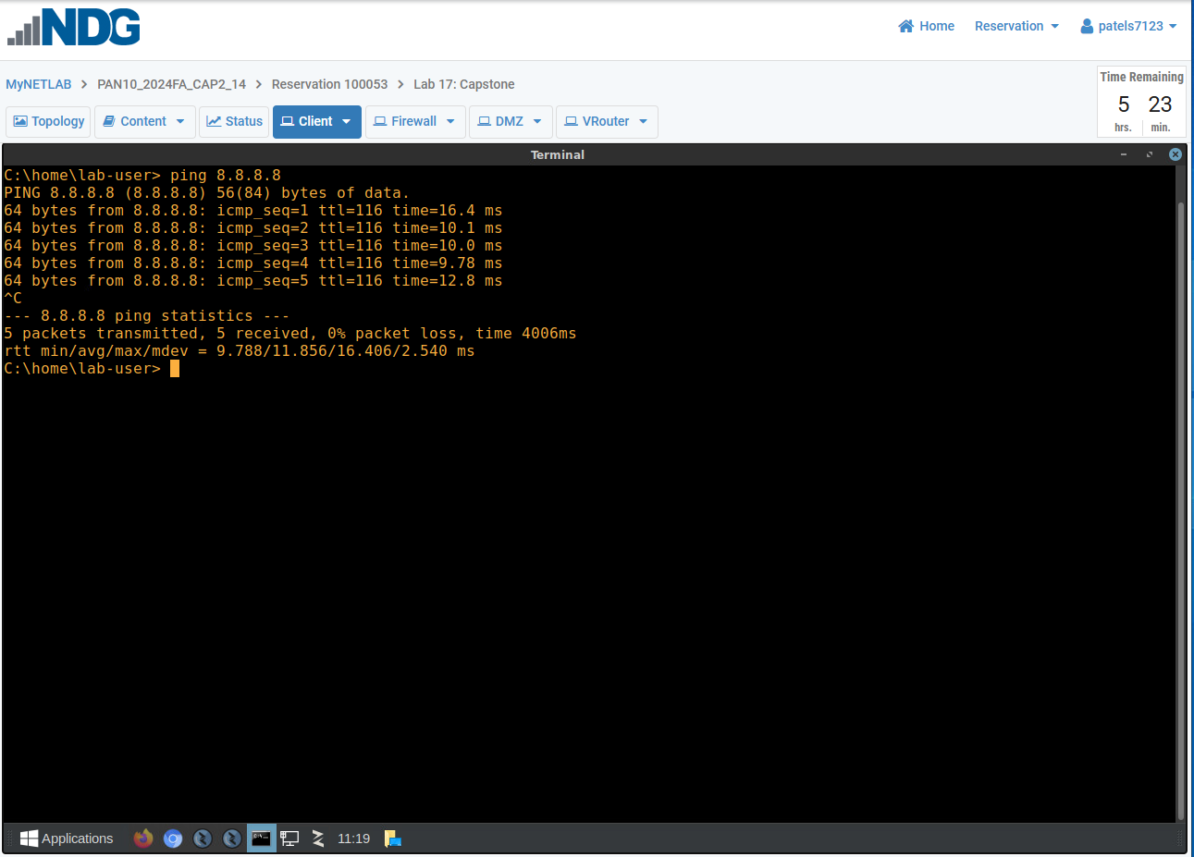

Screenshot 7 - After completing the firewall setup, provide a screenshot showing that the client host, from the client terminal, can ping google.com and receive a response. Do not let the ping run for too long.
The command you entered, and the full ping statistics output, must be visible in your screenshot. Ensure only one command and its output is in the screenshot (i.e. clear the CLI screen prior to conducting the command above).
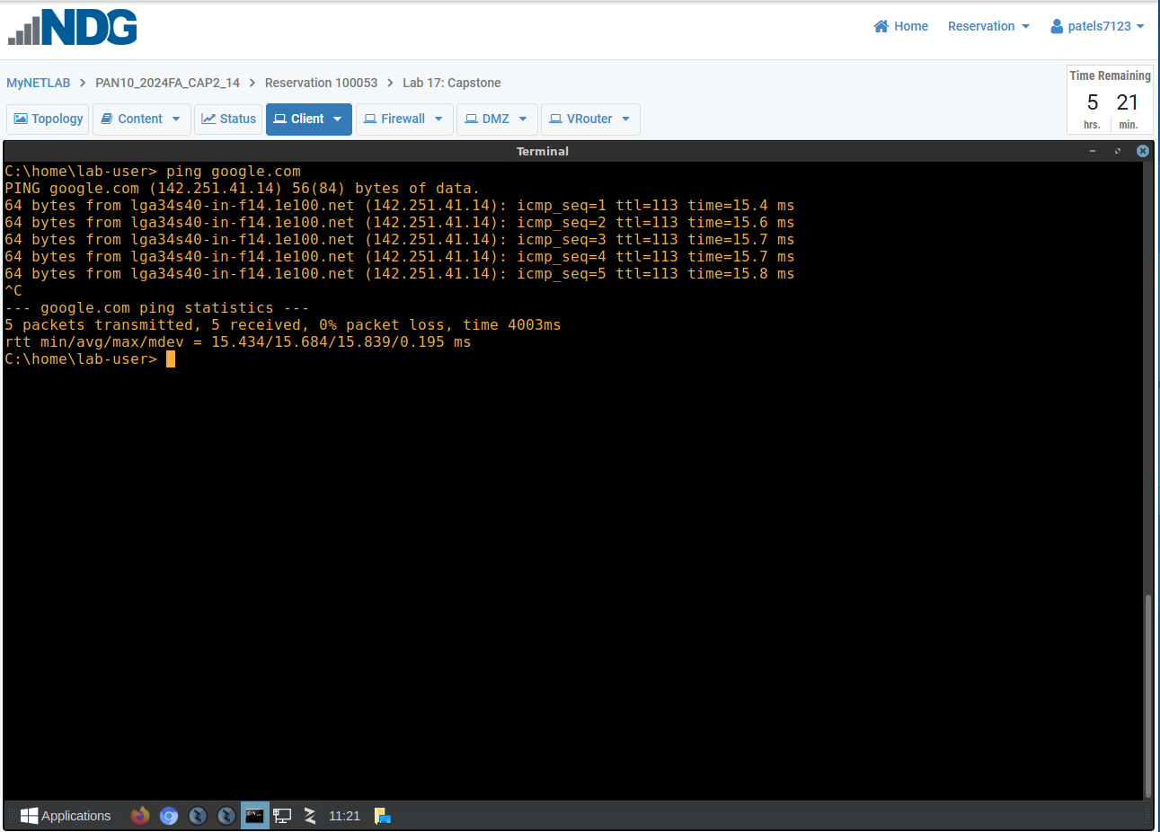

Screenshot 8 - After completing the firewall setup, provide a screenshot showing that the client host can access www.paloaltonetworks.com via the browser.

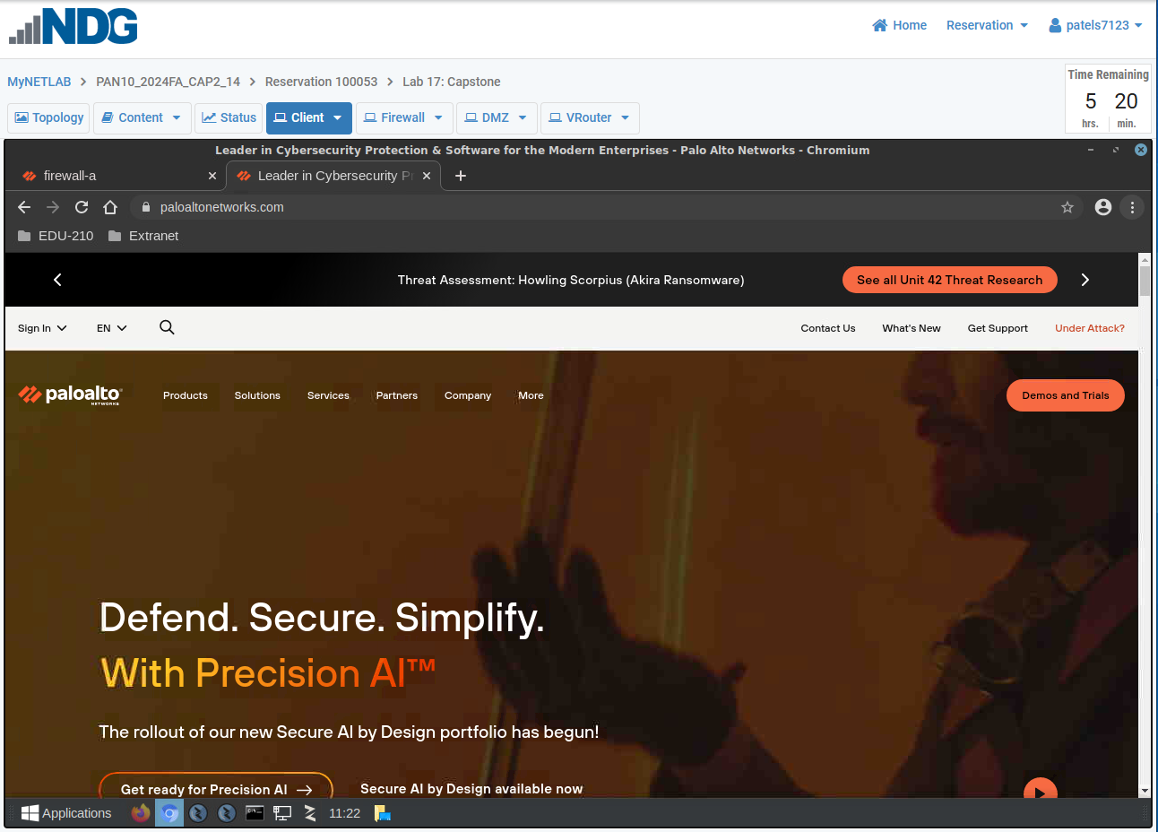

Screenshot 9 - After completing the firewall setup, provide a screenshot showing that the client host can browse to the Extranet web server at http://192.168.50.80
Do not access the site via https for this screenshot

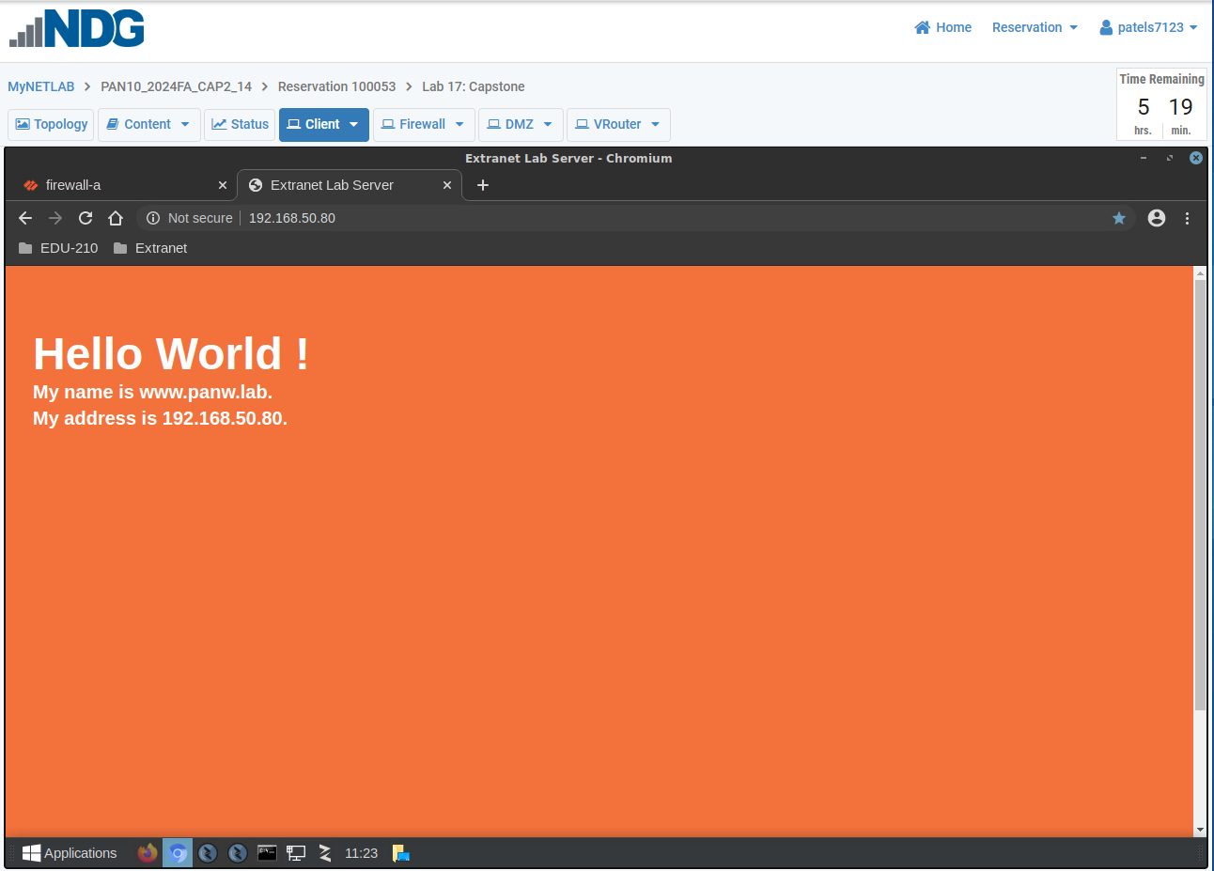

Screenshot 10 - After completing the firewall setup, provide a screenshot showing that the client host, from the client terminal, can use SSH to access the Extranet host at 192.168.50.150 (login to use is paloalto42 and the password is Pal0Alt0!)

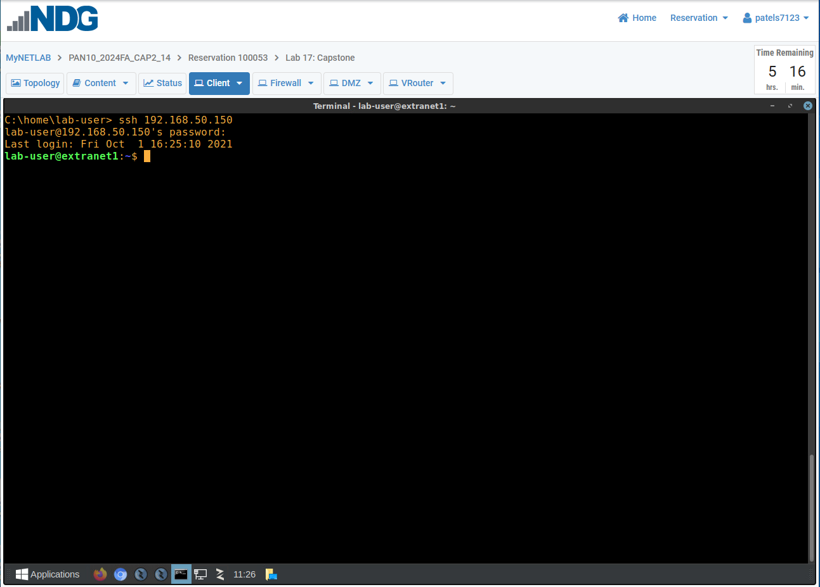

Screenshot 11 - After completing the firewall setup, provide a screenshot showing that from the Extranet host (via Remmina), you can ping 8.8.8.8 and receive a response. Do not let the ping run for too long.
The command you entered, and the full ping statistics output, must be visible in your screenshot. Ensure only one command and its output is in the screenshot (i.e. clear the CLI screen prior to conducting the command above).
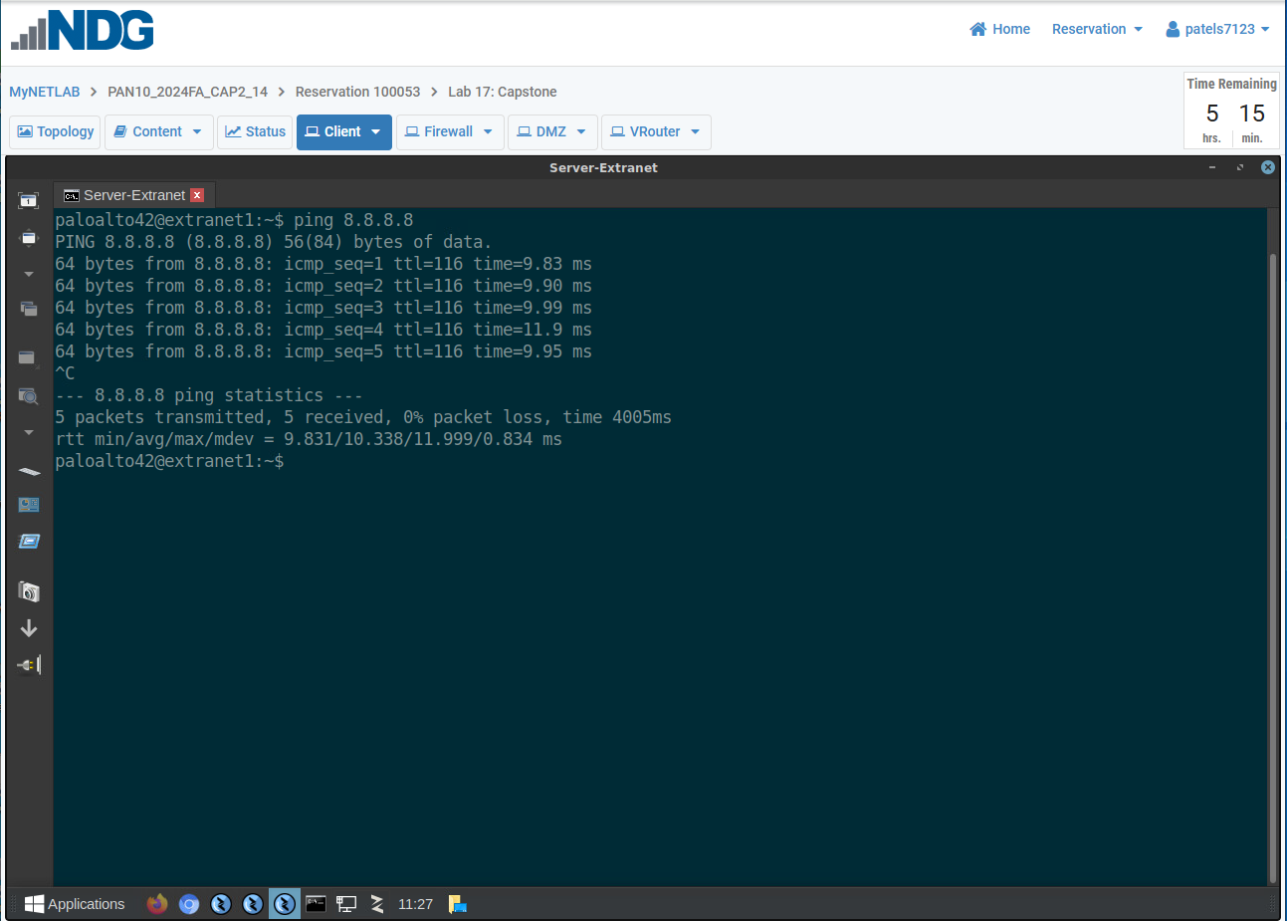

Screenshot 12 - After completing the firewall setup, provide a screenshot showing that from the Extranet host (via Remmina), you can ping google.com and receive a response. Do not let the ping run for too long.
The command you entered, and the full ping statistics output, must be visible in your screenshot. Ensure only one command and its output is in the screenshot (i.e. clear the CLI screen prior to conducting the command above).
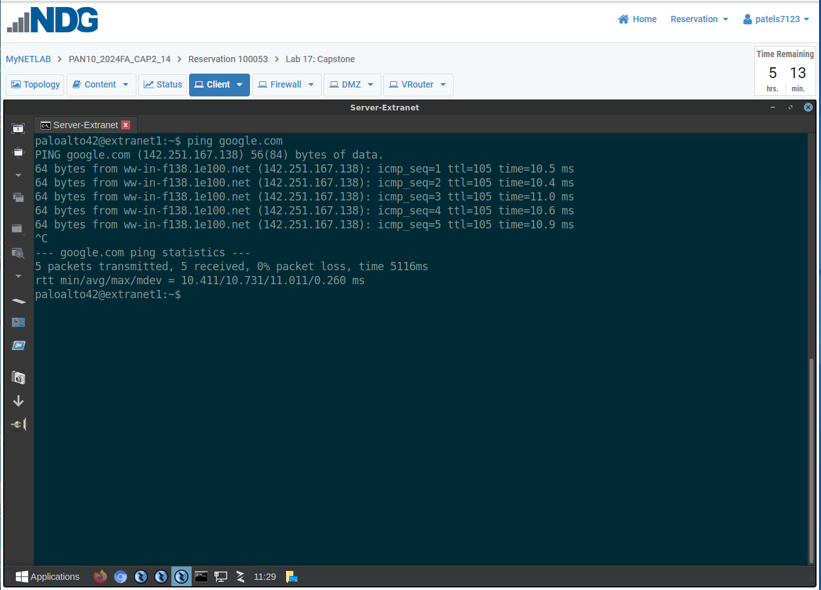

Screenshot 13 - After completing the firewall setup, provide a screenshot showing whether the internal host can reach http://www.hacker9.com via the Firefox browser.

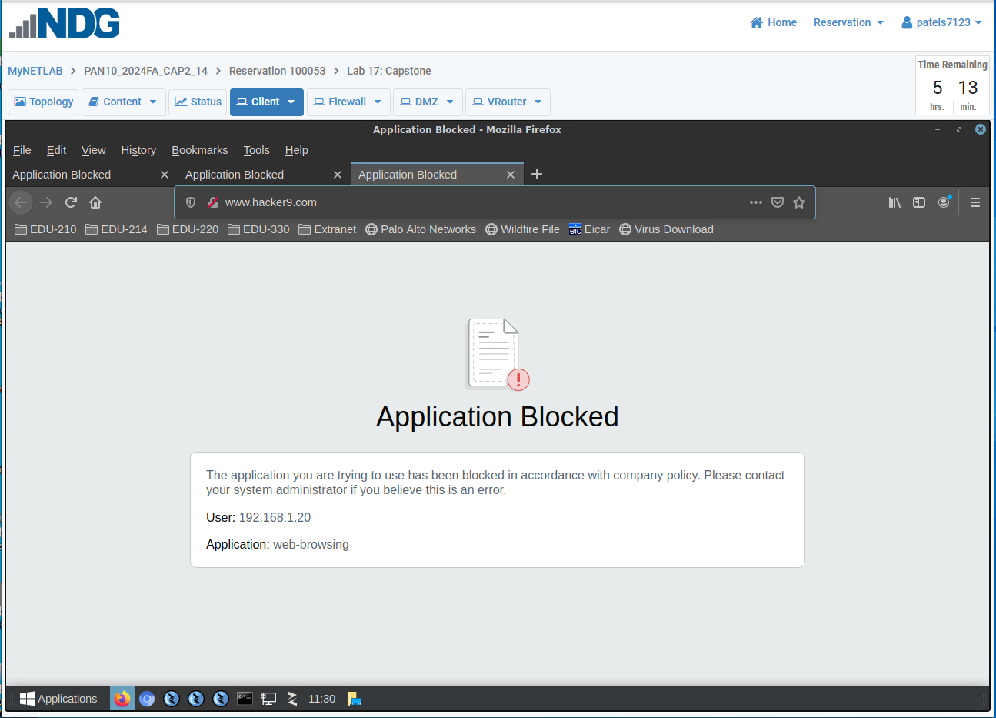

Screenshot 14 – For Objects >Security Profiles > Antivirus, remove all columns, except Decoders Protocol, Decoders Signature Action, and Description. (You should now only have 7 columns on your screen)
After completing the firewall setup, provide a screenshot of Objects>Security Profiles>Antivirus confirming you have completed some of the objectives of the Capstone.
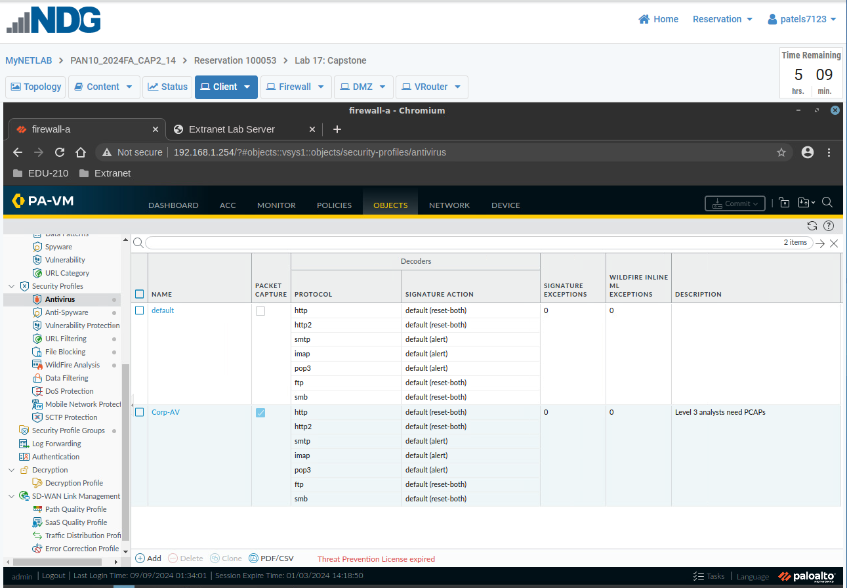

Screenshot 15 - After completing the firewall setup, provide a screenshot of Objects >Security Profiles > Anti-Spyware confirming you have completed some of the objectives of the Capstone. Ensure all necessary columns, column information and changes you made are fully visible in the screenshot.
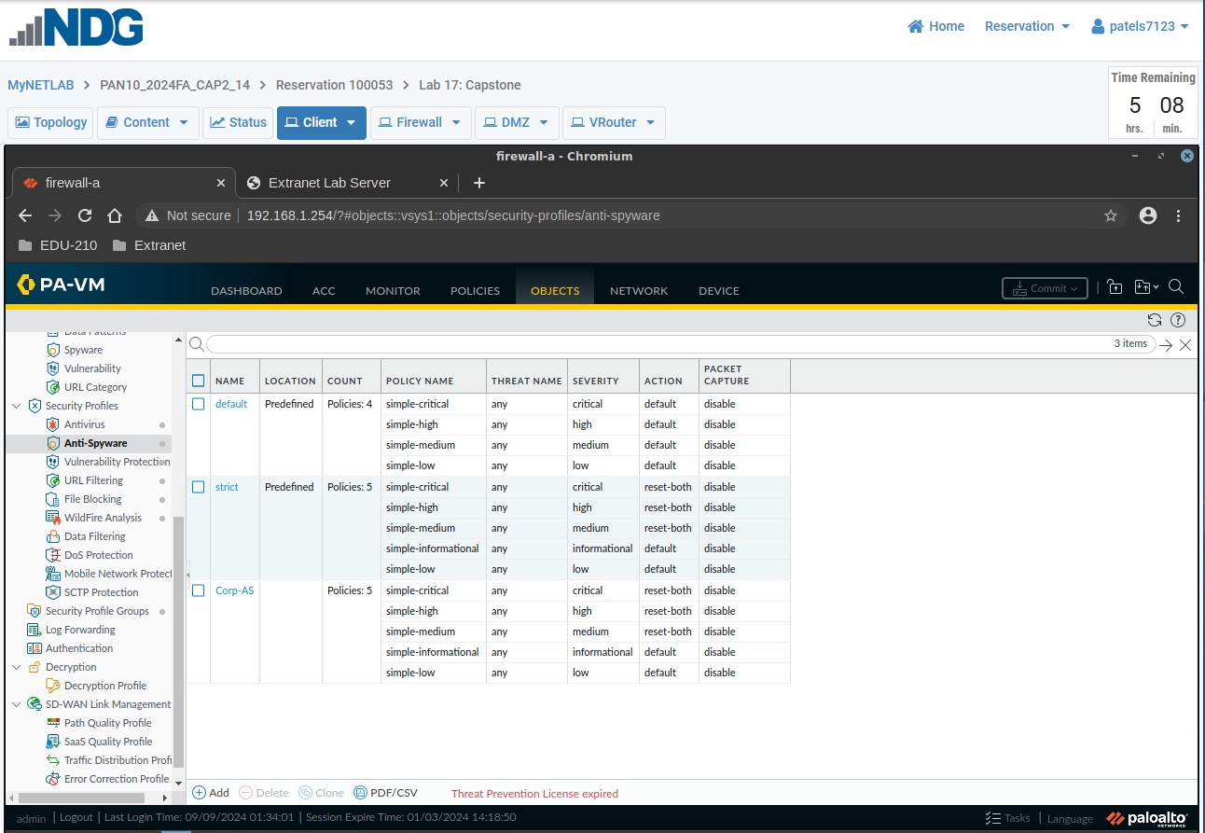

Screenshot 16 - After completing the firewall setup, provide a screenshot of Objects >Security Profiles > Vulnerability Protection confirming you have completed some of the objectives of the Capstone. Ensure all necessary columns, column information and changes you made are fully visible in the screenshot.
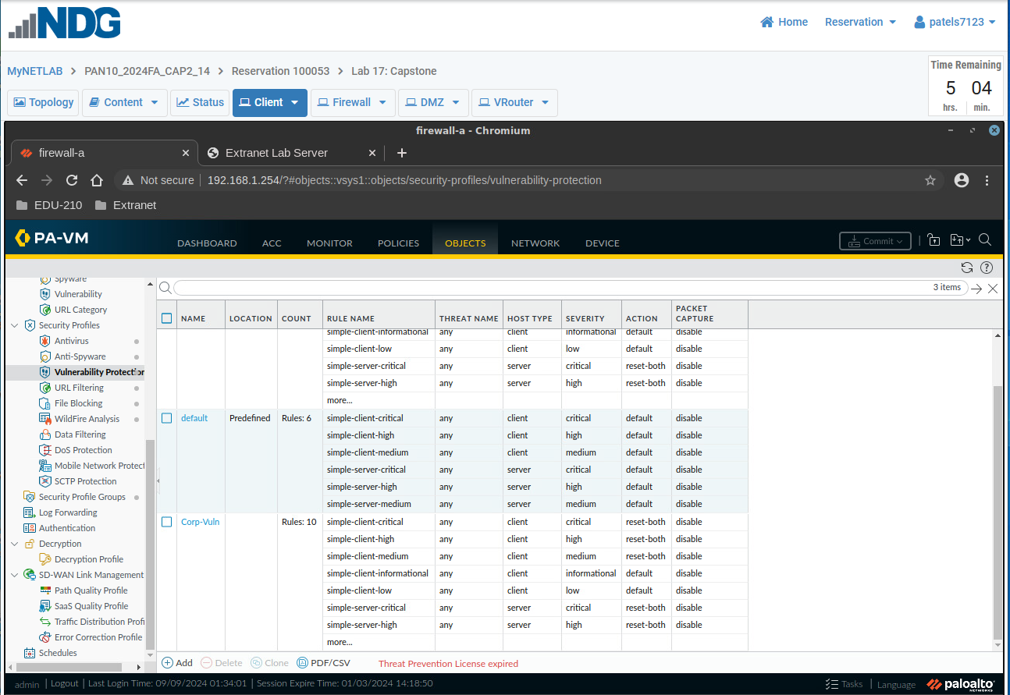

Screenshot 17 - After completing the firewall setup, provide a screenshot of Objects >Security Profiles > URL Filtering confirming you have completed some of the objectives of the Capstone. Ensure all necessary columns, column information and changes you made are fully visible in the screenshot.
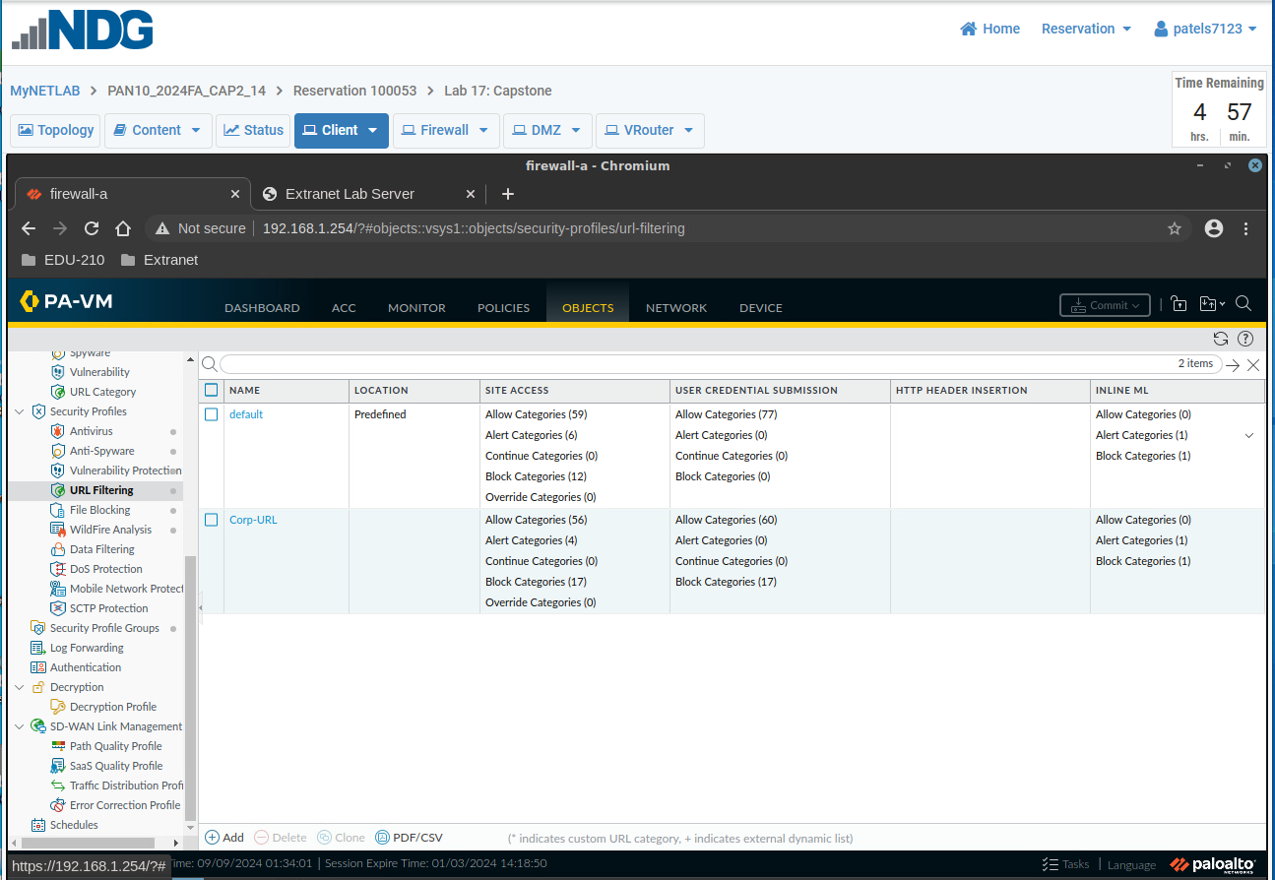

Screenshot 18 - After completing the firewall setup, provide a screenshot of Objects >Security Profiles > File Blocking validating you have completed some of the objectives of the Capstone. Ensure all necessary columns, column information and changes you made are fully visible in the screenshot.
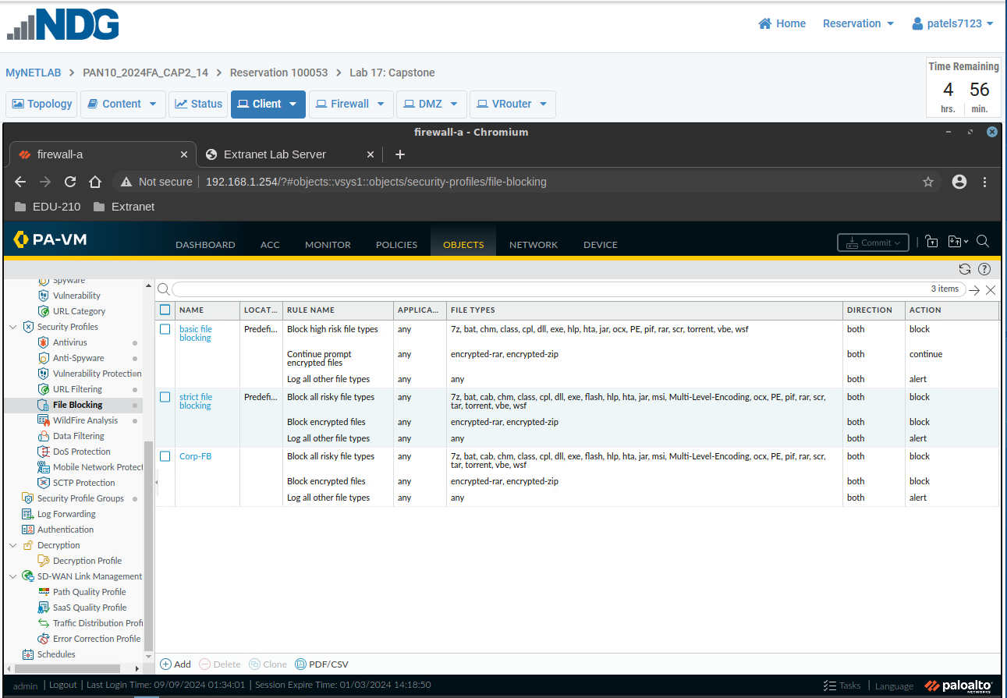

Screenshot 19 - After completing the firewall setup, provide a screenshot of Objects >Security Profiles > WildFire Analysis confirming you have completed some of the objectives of the Capstone. Ensure all necessary columns, column information and changes you made are fully visible in the screenshot.
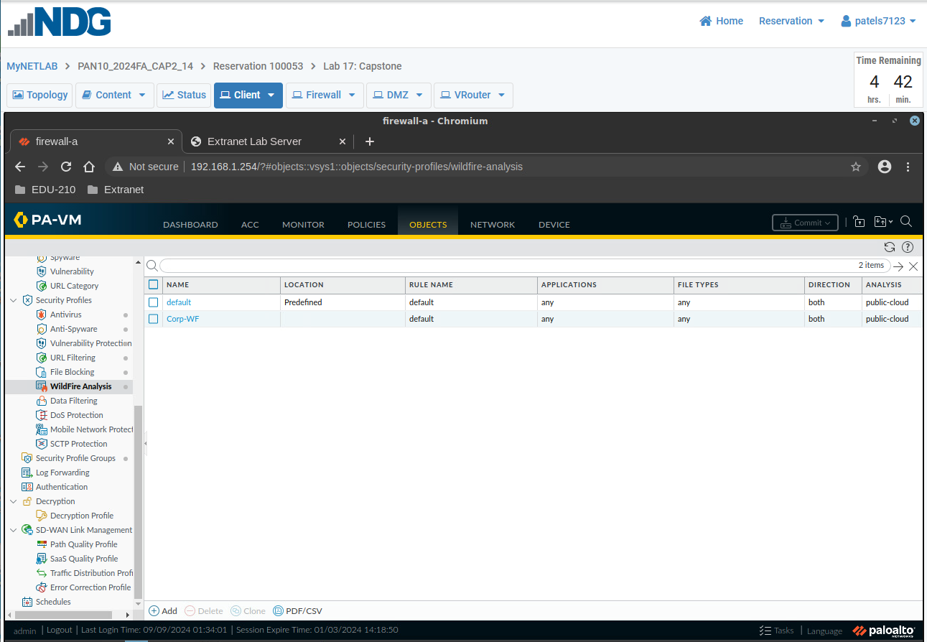

Screenshot 20 - After completing the firewall setup, provide a screenshot confirming you have created the Security Profile Group that meets the objectives of the Capstone. Ensure all necessary columns, column information and changes you made are fully visible in the screenshot.
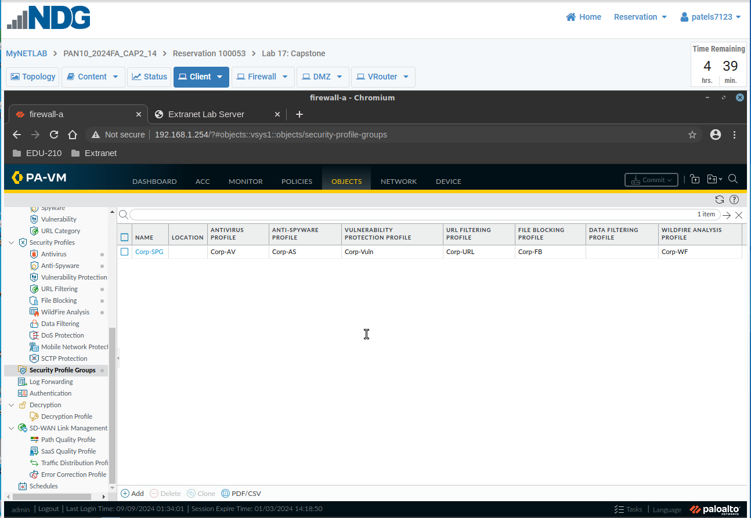

Warning: You are entering a different date and description for the Final Screenshot for Capstone Part 2
You are entering the date and description shown on line two on the top of the next page.

Final Screenshot (Go to Monitor > Logs > System and in the search bar enter the following: (those are single quote marks below)
receive_time geq 2024/11/25 and description contains ‘Capstone’ (Note date and description change)
Take a screenshot of the results
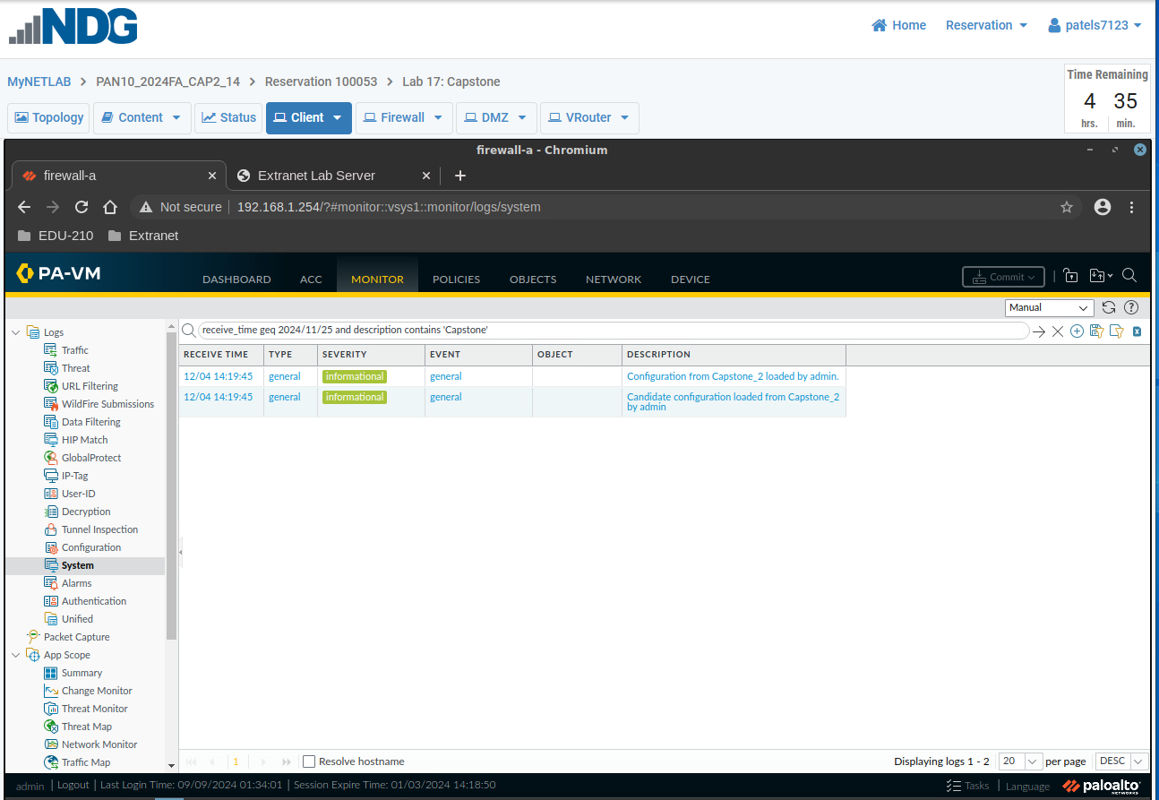

END OF LAB
Remember to save this document as a PDF by choosing Save As and under the name of the file replacing Word Document (*.doc) with PDF (*.pdf) and then clicking on Save.

